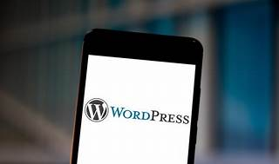

Explore

Certainly! Let’s dive into WordPress frameworks and some free learning resources:

1. **WordPress Frameworks**: A **WordPress framework** is essentially a **code library** that serves as a **building block for theme development**. [It includes basic site functionalities and design elements necessary to improve or create a new website theme1](https://themeisle.com/blog/wordpress-framework/).
2. **Why Learn WordPress?**:
   * **Cost-Effective**: WordPress is **free and open-source**, making it budget-friendly.
   * [**Versatility**: With over 50,000 themes and 10,000 plugins, it can be customized for various projects1](https://themeisle.com/blog/wordpress-framework/).
3. **Learning Timeline**:
   * **Basics**: You can learn the basics of WordPress in **a week or less**.
   * [**Mastery**: To master WordPress, it depends on your goals and how deep you want to dive into customization](https://themeisle.com/blog/wordpress-framework/)[2](https://wpastra.com/resources/learning-wordpress/).
4. **Free Learning Resources**:
   * **WordPress Codex**: The official WordPress site offers **free guides and resources**.
   * **WordPress TV**: Provides video tutorials.
   * **Hostinger.com WordPress Tutorials**: Hostinger offers helpful guides.
   * **Official WordPress Lessons**: Learn directly from WordPress.
   * [**Darrel Wilson**: Check out his tutorials for practical insights](https://themeisle.com/blog/wordpress-framework/)[3](https://www.hostinger.com/tutorials/learn-wordpress).
5. **Additional Resources**:
   * **SkillJet Academy**: Explore their content.
   * **The Astra Blog and YouTube Channel**: Astra provides valuable insights.
   * **Google Search**: Find free tutorials online.
   * [**Other Online Resources**: Smashing Magazine, WP101, WP Sessions, and more](https://themeisle.com/blog/wordpress-framework/)[2](https://wpastra.com/resources/learning-wordpress/).

Happy learning! 🌟📚